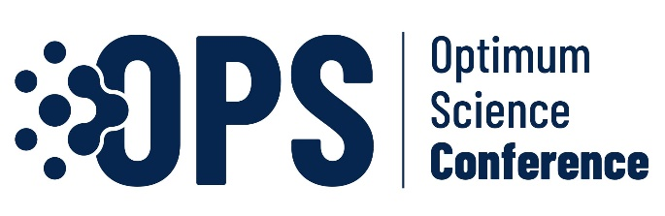 | 1st International Optimum Science Conference 2024  Conference homepage: https://opscon.com.tr

Type the title of paper, Capitalize first letter, 14 point-font size, Bold!

First Author ¹ , Second Author ²

¹ First affiliation, City, Country, Mail
² Second affiliation, City, Country Mail

ABSTRACT
Type your Abstract text here. Abstract should be in Times New Roman (TNR) font and 10-point font size. An Abstract is required for every paper; it should succinctly summarize the aim for the paper, the method, the main findings, and the conclusions of the study. Please provide an abstract of 100 to 150 words. Do not include artwork, tables, elaborate equations or references in Abstract. The reason is that the Abstract should be understandable in itself to be suitable for storage in textual information retrieval systems. Supply some 3 keywords, the first letter of each keyword must start with a capital letter, e.g. Composite, Electron paramagnetic resonance, Physics education and so on.

Keywords: Keyword 1, Keyword 2, Keyword 3

* Foreign authors and authors who will present their work in English do not have to write an abstract in Turkish *
* Yabancı yazarlar ve çalışmasını İngilizce sunacak yazarlar Türkçe özet yazmak zorunda değildir *

